WEEKLY MOBILE HOME RENTAL RATES

2022 SEASON
Season 2022  Mobile home for 4 people |  | Mobile home  (+ de 23m²)
Weeks 20 to 26  ( from May to Saturday 25th July ) |  | 260€ | Offer  3 weeks for 760€
Weeks 26 to 28  ( from July 25th to Saturday 9th July ) |  | 395€ | Offer  3 weeks for 1000€
Weeks 28 to 30  ( from July 9th to Saturday 23rd July ) |  | 490€ | Special  offer 460€o
Weeks 30 to 34  ( from July 23rd to Saturday 20th August ) |  | 600€
Weeks 34 to 35  (from August 20th to Saturday 27th August) |  | 490€ | Offer  3 weeks for 900€
Weeks 35 to 37  ( from August 27th to September ) |  | 260€

DAILY CAMPING PITCH RATES FROM MAY TO SEPTEMBER
90 m² pitch on average, bordered by trees,  5 people maximum. Available from 12 H to 11 H. | May, June, September 2022 | July, August  2022
1 Person  Pitch, 1 Car, Washroom, Swimming pool | 12.00 € | 15.00 €
Package 2 People,  Pitch, 1 Car, Washroom, Swimming pool | 15.00 € | 20.00 €
Additional person : | 4.00 € | 6.00 €
Child aged below 7 years old : | 3.00 € | 3.50 €
Animal : tattoo and Rabies vaccine are mandatory  First and second category dogs are not allowed  ADDITIONAL CARS | 2 €  2 € | 2 €  2 €
Electrical terminal : 6 Amps.  Bring long electrical cable and franco-european adapter | 4, 00 € | 4, 00 €
+ Visitation tax : 0.39€/ day.

_ _ _ _ _ _ _ _ _ _ _ _ _ _ _ _ _ _ _ _ _ _ _ _ _ _ _ _ _ _ _ _ _ _ _ _ _ _ _ _ _ _ _ _ _ _ _ _ _ _ _ _ _ _ _ _ _ _ _ _ _ _ _ _ _ _ _ _ _ _ _ _ _ _ _ _ _

BOOKING FORM TO BE RETURNED

- Last name and first Name :………………………………………………………………….
- Full address :………………………………………………………………………………….
- Email :………………………………………………………- Phone :……………………….
- Arrival date : …………………………..….Departure date :……………………………….

« I, the undersigned, after having read and understood the terms and conditions, confirm that I will honour my booking. » :

Pitch booking for tent or private caravan.
Number of pitches : ………… Adults :…………….. Children (- 7 yo) :………………………
With electrical connection : YES NO
Deposit : 100 € ( + 10 € for administrative fees) or 110 € per pitch.

Rent 4-people mobile home (2 bedrooms) ( 23m²)
Number of inhabitants: Adults :…………….. Children (- 7 yo) :………………………
Do you wish to install a tent on the pitch ? YES NO
Deposit : 30 % of the rent + 15 € for administrative fees, or :……………………€
(example :580 € x 30 % = 174€ + 15 € for administrative fees = 189 €).

WE ASK THAT YOU SPECIFY THE LAST NAMES, FIRST NAMES AND DATES OF BIRTH OF ALL THE INHABITANTS.

To make a booking, please return this booking form along with the deposit.

The deposit can be paid by cheque, payment order or holiday vouchers denominated in the order of :

CAMPING VAL ROMA PARK – LES THERMES DU BOULOU – 66480 MAUREILLAS LAS ILLAS,

« I hereby declare that I accept the institution’s rates, and confirm that I will pay for my stay (including visitation tax) and that I will leave an additional 250 € deposit if I am renting accommodation. »

Signed at :…………………………………………………. Date :………………….. Signature :

TERMS AND CONDITIONS FOR MOBILE HOME RENTAL AND CARAVANS:

1) RATES : Rental rates include water, electricity, gas, a parking space, access to the swimming pool and the car park (movement in the campsite is forbidden between 23 H and 7 H 00, parking at the entrance of the campsite is mandatory.)
Extras are described in the table below and apply to each stay.

2) SCHEDULE :
Reception : July and August: reception takes place from 10 H to 12 H and from 16 H to 18 H EXCEPT ON SUNDAY AFTERNOONS
Out of season: from 10 H to 12 H and from 17H to 18 H from Monday to Friday,
Answering machine available during an absence.

Rentals : July and August: Accommodation is rented from Saturday 15 H 00 (arrival day) to the next Saturday 11 H (departure day). In the event of morning arrival, you will have to wait, and in the event of late arrival (past 7 pm) please notify us beforehand.
Out of season : Departures and arrivals at other times of the week are accepted (except Sundays), ask reception about availabilities.
Pitches : Pitches for tents and private caravans are available from 12 H on the day of arrival until 11 H at the latest on the day of departure. In you happen to overrun, an additional day will be charged.
Pitches are invoiced on a nighlty basis, and will be kept free on arrival day (subject to availability).

3) DELAY / CANCELLATION :
If you fail to notify us of a delay, the rental will be kept free until the next day 14 H. Beyond this, we will make use of the mobile home and keep the deposit.
No discount will be given in the event of a delayed arrival or early departure.
No refunds on the deposit or the rent in case of cancellation or interruption of your stay.

4) DEPOSIT :
Accessing the rental is subject to an inventory check of the contents and state of the property.
A deposit of 200 € (by cheque) for contents and premises and of 50 € (cheque) for the state of the property will be asked for on the day of your arrival. The deposit will only be returned after the departure inventory has been done and the keys and the access keychain have been returned, subject to no damage being caused and the property being left clean. In the case of departure during the night, the deposit will be reimbursed by courier after all the checks have been done.
If you desire, you can pay an additional 40€ for cleaning on the day of departure, this service does not include dishes, stains on the floor, equipment, mattresses, and curtains.

5) PAYMENT :
The total cost of the stay and extras is payable on arrival. You can also pay in instalments before your arrival, in the case of which you will need to specify on the back of every cheque the desired date of deposit. Holiday vouchers are accepted as a mean of payment.

6) BOOKING :
The booking is registered under your name, it can’t be transferred. The booking will not be confirmed until the deposit (30% of the rent for mobile homes or 100 € per pitch) and the administrative fees (10€ per pitch or 15€ per mobile home) are paid. This document is used as a booking agreement once the booking is confirmed, after the cheque has been deposited.
Any customer of the campsite will need to follow our safety requirements and our code of conduct. Due to regulations set by the local council, individual barbecues and open fires are forbidden. A communal barbecue is available to all the customers.
Grills, fryers, barbecues et other electronic appliances that require more than 6 amps (1 320 watts) will not function because of limited current. Electrical stoves and barbecues are forbidden.

7) DESCRIPTION OF THE MOBILE HOME :
- kitchen area (refridgerator, 4-hob stove, dishes, cutlery and utensils, coffee machine).
- indoor and outdoor dining area (patio), living room area with bench seat.
- bathroom with toilets, shower and sink.
- first bedroom with double bed (140 x 190), second bedroom with 2 individual beds (80 x 190).
Mobile homes are equipped with dishes, pillows, a terrace, and a patio.
Bedsheets, pillowcases and blankets are not provided for sanitary reasons.
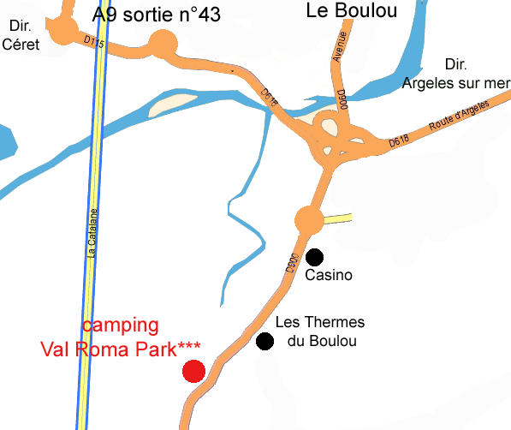
The pitches are 90 to 100 m² on average and surrounded by trees.

ACCESS TO CAMPSITE

From L’AUTOROUTE A 9 :
Sortie n°43, LE BOULOU,
Take D 900 direction Le Perthus (Gérone), Les Thermes du Boulou.
From la départementale 900 :
Direction Le BOULOU, Les Thermes du Boulou
The campsite is located 500m past from the geothermal site.

